Graphic Accelerator Specification

2006-07-31

- Registers
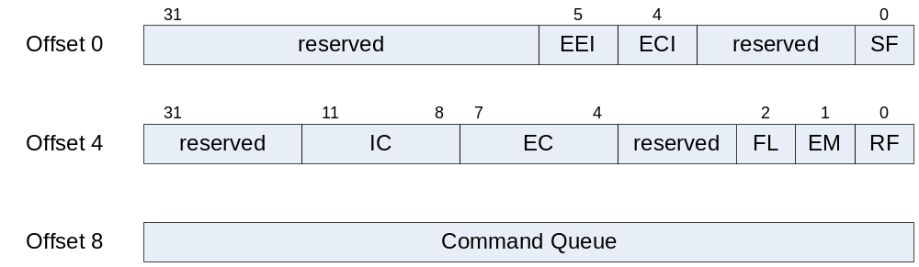
  - Control Register
    - Start Flag(SF)
      - Operation Start Command Flag
    - Interrupt Enable Flag
      - ECI : Enable Complete Interrupt
      - EEI : Enable Error Notice Interrupt
      - Others : reserved
  - Status Register
    - RF : Running flag
      - 현재 operation 수행중임을 알림
    - EM : Command queue empty
    - FL : Command queue full
    - EC : Error Code
      - Error Kind
      - If 0, no error
    - IC : Interrupt Code
      - Interrupt Kind
      - If 0, no interrupt
  - Pointer of the Command Structures
    - Store the pointer of commands to queue
    - 여러 개의 command structure가 linked list로 연결
    - Next Pointer가 0x0이면 다음 command가 없음을 의미
    - Read시 최종 수행한 command의 pointer를 저장하고 있음

